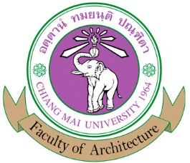
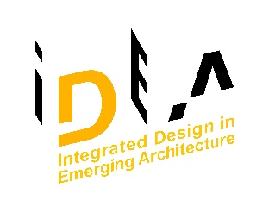

Bachelor of Science Program in Integrated Design in
Emerging Architecture (International Program)
I.D.E.A. 4-year B.Sc. Program (Non-Professional Degree Program)
STUDY PLAN
Study Plan for Bachelor of Science Program in
Integrated Design in Emerging Architecture (International Program)
Total credits 141 credit

First Year
First Semester Credits
801105 | ARCT 105 | Learning Through Activities 1 | 2(0-6-2)
801106 | ARCT 106 | Learning Through Activities 2 | 1(0-3-1)
804121 | ARCI 121 | History of Eastern Creative Arts and Architecture | 3(3-0-6)
804111 | ARCI 111 | Fundamental Design in Architecture Studio 1 | 5(1-8-6)
001101 | ENGL 101 | Fundamental English 1 | 3
 |  | Humanities and Social Science | 3
 |  | Science and Mathematics | 3
Total |  |  | 20

Second Semester Credits
001102 | ENGL 202 | Fundamental English 2 | 3(3-0-6)
804112 | ARCI 112 | Fundamental Design in Architecture Studio | 5(1-8-6)
804102 | ARCI 102 | Human Behavior and Built Environment | 3(3-0-6)
 |  | Science and Mathematics | 3
 |  | Humanities and Social Science | 3
 |  | Humanities and Social Science | 3
Total |  |  | 20

Second Year
First Semester Credits
804201 | ARCI 201 | Design Communication and Presentation | 3(2-2-5)
804211 | ARCI 211 | Creative Design in Architecture Studio 1 | 5(1-8-6)
804221 | ARCI 221 | Perception of Architectural Space | 3(3-0-6)
804222 | ARCI 222 | History of Western Creative Arts and Architecture | 3(3-0-6)
804231 | ARCI 231 | Materials and Construction 1 | 3(3-0-6)
001201 | ENGL201 | Critical Reading and Effective Writing | 3
Total |  |  | 20

Second Semester Credits
001202 | ENGL 202 | English in Professional Contexts | 3
804202 | ARCI 202 | Theory in Digital Communication and Creative Computer Aided Design | 3(2-2-5)
804212 | ARCI 212 | Creative Design in Architecture Studio 2 | 5(1-8-6)
804232 | ARCI 232 | Materials and Construction 2 | 3(1-4-4)
804233 | ARCI 233 | Basic Building and Energy Systems | 3(1-4-4)
804234 | ARCI 234 | Architectural Structure 1 | 3(1-4-4)
Total |  |  | 20

Third Year

First Semester Credits
804311 | ARCI 311 | Creative Design in Architecture Studio 3 | 5(1-8-6)
804321 | ARCI 321 | Theory and Philosophy of Postmodern Arts and Architecture | 3(3-0-6)
804331 | ARCI 331 | Applied Building and Energy System | 3(1-4-4)
804332 | ARCI 332 | Architectural Structure 2 | 3(2-2-5)
804371 | ARCI 371 | Sustainable Urban Architecture and Communities | 3(3-0-6)
 |  | Free Elective | 3
Total |  |  | 20

Second Semester Credits
804312 | ARCI 312 | Creative Design in Architecture Studio 4 | 5(1-8-6)
804322 | ARCI 322 | Theory and Philosophy of Contemporary Thai Arts and Architecture | 3(3-0-6)
804333 | ARCI 333 | Advanced Architectural Structure | 3(1-4-4)
804372 | ARCI 372 | Integrated Fields and Systems in Architecture and Urbanism | 3(3-0-6)
 |  | Free Elective | 3
Total |  |  | 17

Fourth Year

Track 1
First Semester Credits
804411 | ARCI 411 | Selected Topics in Architectural Design Studio | 3(0-6-3)
804481 | ARCI 481 | Architecture Internship | 3(0-6-3)
Total |  |  | 6

Track 2
First Semester Credits
804482 | ARCI 482 | Cooperative Education | 6(0-30-0)
Total |  |  | 6

Second Semester (Both Track 1 and Track 2)
Second Semester Credits
804412 | ARCI 412 | Creative Design in Architecture Studio 5 | 6(1-10-7)
804483 | ARCI 483 | Principle in Architecture Professional Practice | 3(3-0-6)
 |  | Major Elective | 3
 |  | Major Elective | 3
 |  | Major Elective | 3
Total |  |  | 18

